Clustering Algorithm my Approach
First, I used the K means Clustering algorithm for speed and ease of implementation. But Later, it turned out for a given dataset the centroids chosen will divide the data equally distributed as follows. Hence, it is great to follow a density based clustering (DBSCAN) algorithm.

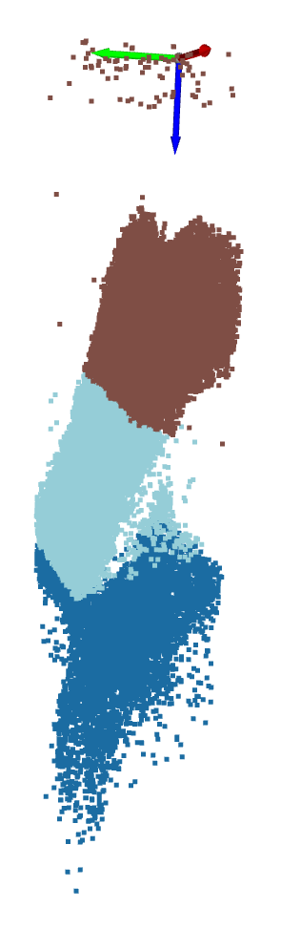

kmeans_cluster_result_oct-1-small.png

DBSCAN:
I started working on a small dataset ‘oct-2-small.pcd’. After DBSCAN has clustered the point cloud, I need to classify the dataset close to Z=0 and greater than threshold no.of points as DURA. Further, dataset faraway from Z=0 and greater than threshold no.of points as CORTICAL. And the rest as UNKNOWN.
I took the z_threshold based on the average of centroids of all clusters.

My input params:

const float cluster_tolerance = 10.0; // Increased distance threshold for clustering
const int min_cluster_size = 5; // Reduced minimum number of points to form a cluster
const int max_cluster_size = 12000; // Maximum number of points in a cluster

I have figured the cluster_tolerances and min_cluster_size by sorting the dataset based on z values and printing the top-10 z values to understand the input params to be provided visually.

My result for Oct-2-small was close to ground truth as below:
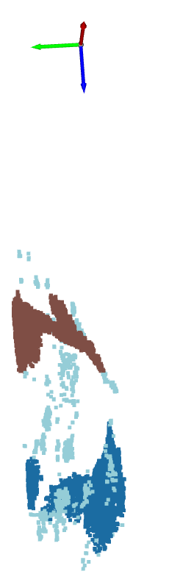

oct-2-small.png

Using the same algorithm on ‘Oct-1-small.pcd’ dataset didn’t yield a good result as below:

Input params:
const float cluster_tolerance = 10.0; // Increased distance threshold for clustering
const int min_cluster_size = 5; // Reduced minimum number of points to form a cluster
const int max_cluster_size = 35000; // Maximum number of points in a cluster
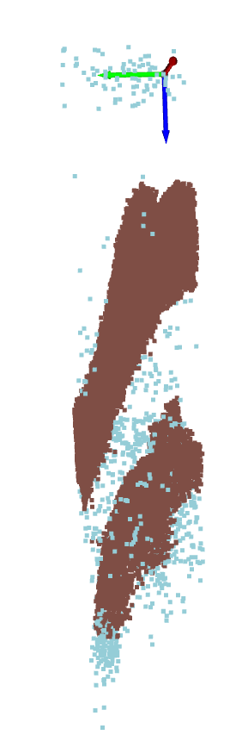
oct-1-small_bad_clustering.png

On further research I have taken the top and bottom most cluster average as the Z_threshold. This yielded me a better result:

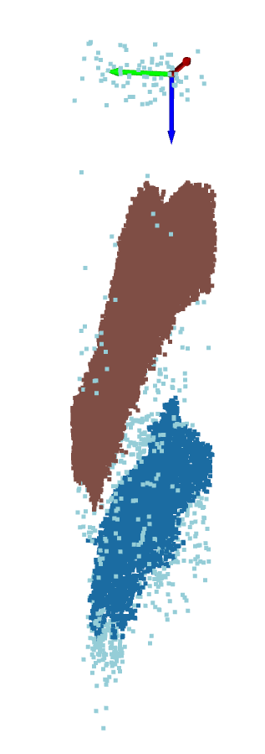
oct-1-small.png
The following is the result for the ‘oct-3-small.pcd’ much better than given growth truth But I am having this result using KD-Tree PCL library(3rd party libraries):
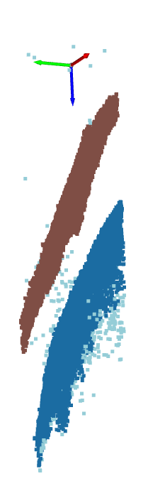
oct-3-small_with_PCL.png

Since I was instructed not to use any “3rd party tools”. Performing Clustering for ‘oct-3-small.pcd’ dataset using my C++ algorithm (DBSCAN approach). It yielded me this:
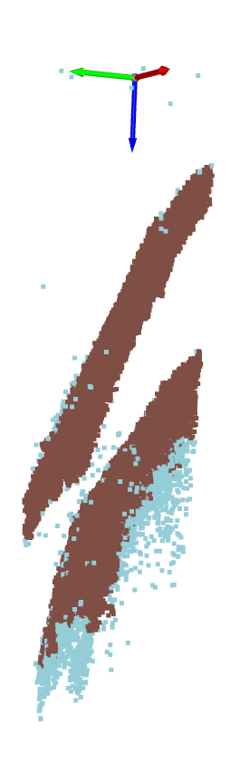
oct-3-small.png

With further debugging my clustering algorithm, I am sure to get the required result.

The following is my result for the ‘oct-2-medium.pcd’ dataset without using and 3rd party tools: max_cluster_size = 160000; const float cluster_tolerance = 10.0; const int min_cluster_size = 5;
Note: It takes around 10-12 min for clustering this huge dataset
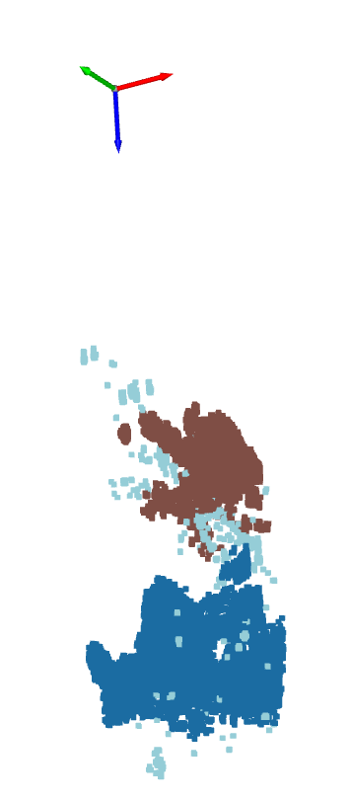

oct-2-medium.png

